Task on VPC Transit Gateway & VPC Endpoint

- Create one VPC, with 1 public subnet and 1 private subnet.
- Enable VPC peering for cross-region.
- Enable VPC peering for cross-account (you can collaborate with your friend to do this task).
- Set up a VPC Transit Gateway.
- Set up a VPC Endpoint.

Task | What we will create
1 | 1 VPC + 1 Public Subnet + 1 Private Subnet
2 | Cross-region VPC Peering
3 | Cross-account VPC Peering
4 | VPC Transit Gateway
5 | VPC Endpoint

1: Create one VPC, with 1 public subnet and 1 private subnet.
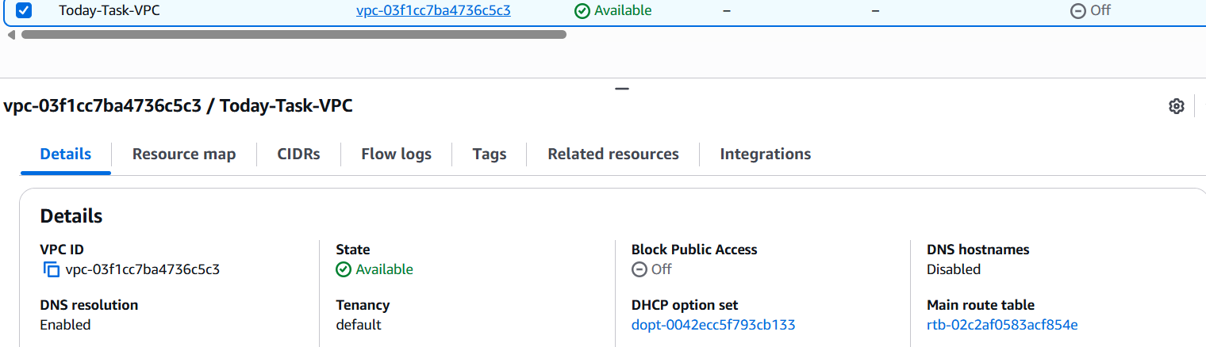
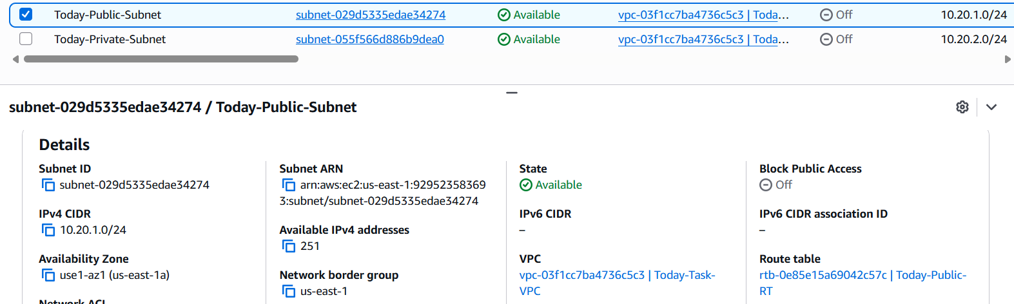
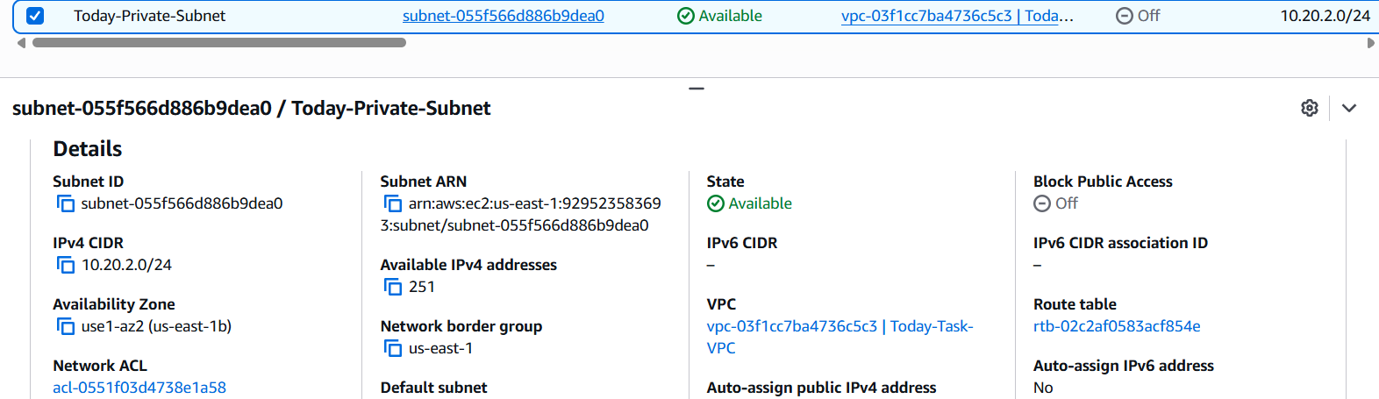
Now have done exactly:
Today-Task-VPC
10.20.0.0/16
│
├── Public Subnet
│ 10.20.1.0/24
│ us-east-1a
│ Public IP: Enabled
│ Today-Public-RT → Internet Gateway
│
└── Private Subnet
10.20.2.0/24
us-east-1b
Public IP: Disabled
Main Route Table

2: Enable VPC peering for cross-region.
Goal: Connect two VPCs in different AWS Regions.
Steps
- Create a second VPC in another region.
  - Today-Task-VPC → us-east-1 → 10.20.0.0/16
  - Task2-West-VPC → us-west-2 → 10.30.0.0/16
- Go to VPC → Peering Connections → Create Peering Connection.
- Select:
  - This Region: us-west-2
  - Another Region: us-east-1
  - Accepter VPC: Today-Task-VPC
- Switch to us-east-1 and Accept the peering request.
- Wait until status becomes Active.
- Add routes in both VPCs:
  - us-east-1: 10.30.0.0/16 → Peering Connection
  - us-west-2: 10.20.0.0/16 → Peering Connection
Remember
VPC Peering = Connect 2 VPCs
Different regions = Cross-Region Peering
Routes are required in BOTH VPCs for traffic to flow.

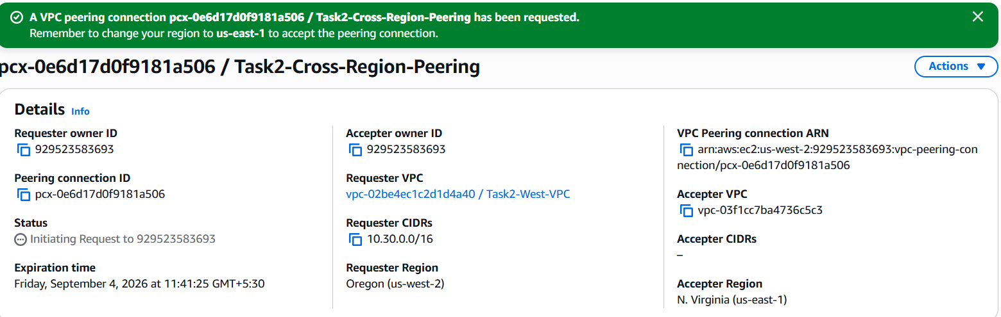

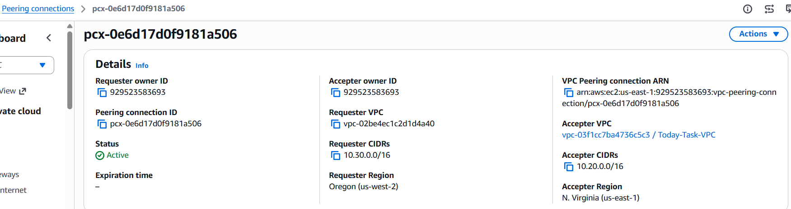
Now it is Active.
Your cross-region VPC peering is successfully established:
us-west-2 us-east-1
Task2-West-VPC Today-Task-VPC
10.30.0.0/16 ←→ 10.20.0.0/16
pcx-0e6d17d0f9181a506
ACTIVE ✅

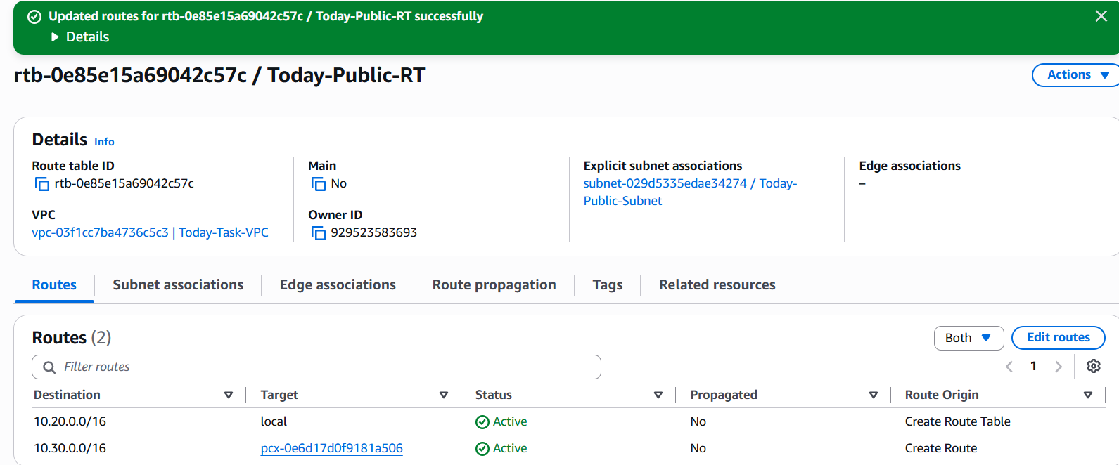
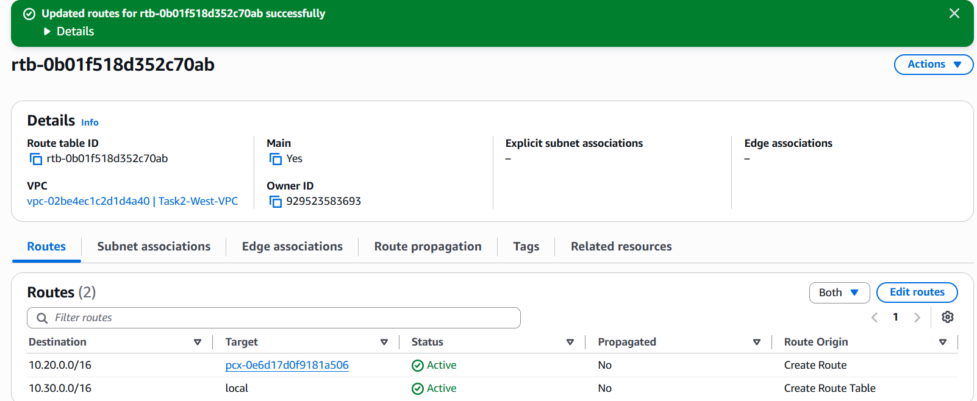
Final setup is correct:
us-east-1 us-west-2
Today-Task-VPC Task2-West-VPC
10.20.0.0/16 10.30.0.0/16
│ │ |
└──── pcx-0e6d17d0f9181a506 ──────┘
ACTIVE
And the routes are correct:
us-east-1:
10.30.0.0/16 → Peering Connection ✅
us-west-2:
10.20.0.0/16 → Peering Connection ✅
🎯 Task 2: Enable VPC peering for cross-region — DONE.
3: Enable VPC peering for cross-account (you can collaborate with your friend to do this task).
My VPC:
- Account: 929523583693
- VPC: vpc-03f1cc7ba4736c5c3
- CIDR: 10.20.0.0/16
- Region: us-east-1
Friend's VPC:
- Account ID: 598122633072
- VPC: vpc-0c3457627797ca02b
- CIDR: 10.0.0.0/16
- Region: us-east-1
--------------------------------------------------------------------------
- VPC → Peering connections → Create peering connection
- Use:
- Name: Task3-Cross-Account-Peering
- Requester VPC: Today-Task-VPC
- Accepter account: Another account
- Account ID: 598122633072
- Accepter VPC: vpc-0c3457627797ca02b
- Region: us-east-1
- Then click Create peering connection.
- Stop after creating it. Your friend will need to accept the request from their AWS account.

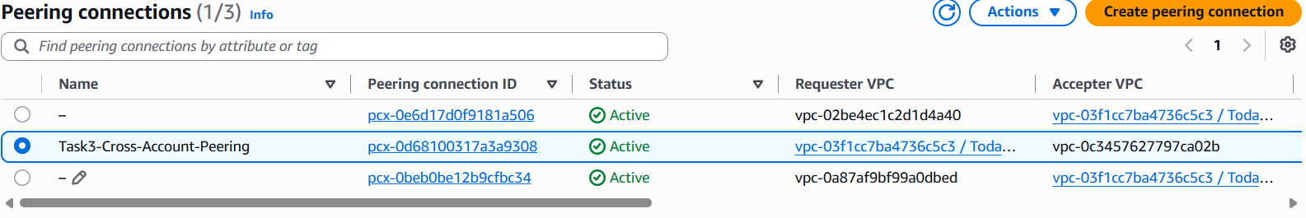
4: Set up a VPC Transit Gateway.
Goal: Create a Transit Gateway and connect a VPC to it.
Steps
- Go to VPC → Transit Gateways.
- Click Create transit gateway.
- Name it:
Task4-Transit-Gateway
- Leave settings as default → Create.
- Go to Transit Gateway Attachments.
- Click Create transit gateway attachment.
- Select:
  - Transit Gateway: Task4-Transit-Gateway
  - Attachment type: VPC
  - VPC: Today-Task-VPC
- Select one subnet for the attachment.
- Click Create transit gateway attachment.
- Wait until attachment State = Available.
Your resources
- Transit Gateway: tgw-0833369c2005363e6
- VPC Attachment: tgw-attach-04595a3c64ad7be79
- Status: Available ✅
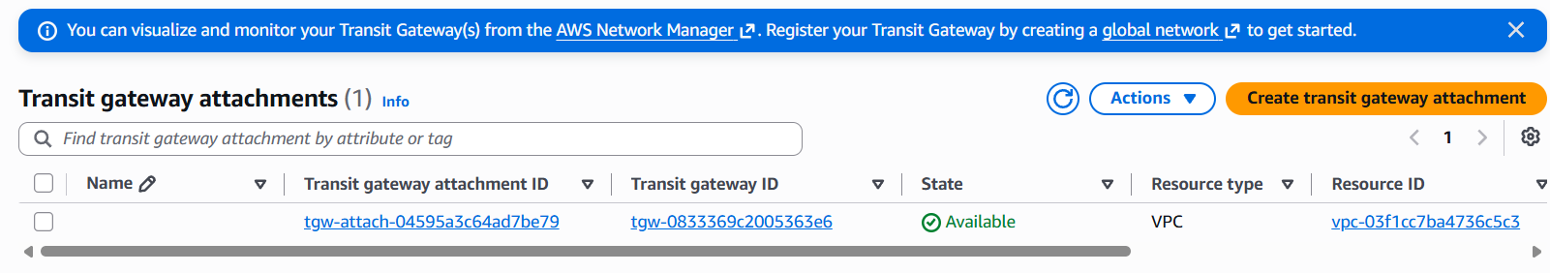

5: Set up a VPC Endpoint.
Goal: Allow a VPC to access an AWS service privately without using the public internet.
Steps
- Go to VPC → Endpoints.
- Click Create endpoint.
- Enter name:
Task5-S3-Endpoint
- Select AWS services.
- Select:
com.amazonaws.us-east-1.s3
- Choose Gateway type.
- Select VPC:
Today-Task-VPC
- Select the appropriate route table.
- Click Create endpoint.
- Verify the endpoint is successfully created.
Your Endpoint
vpce-0b1b86b455b8cf70b

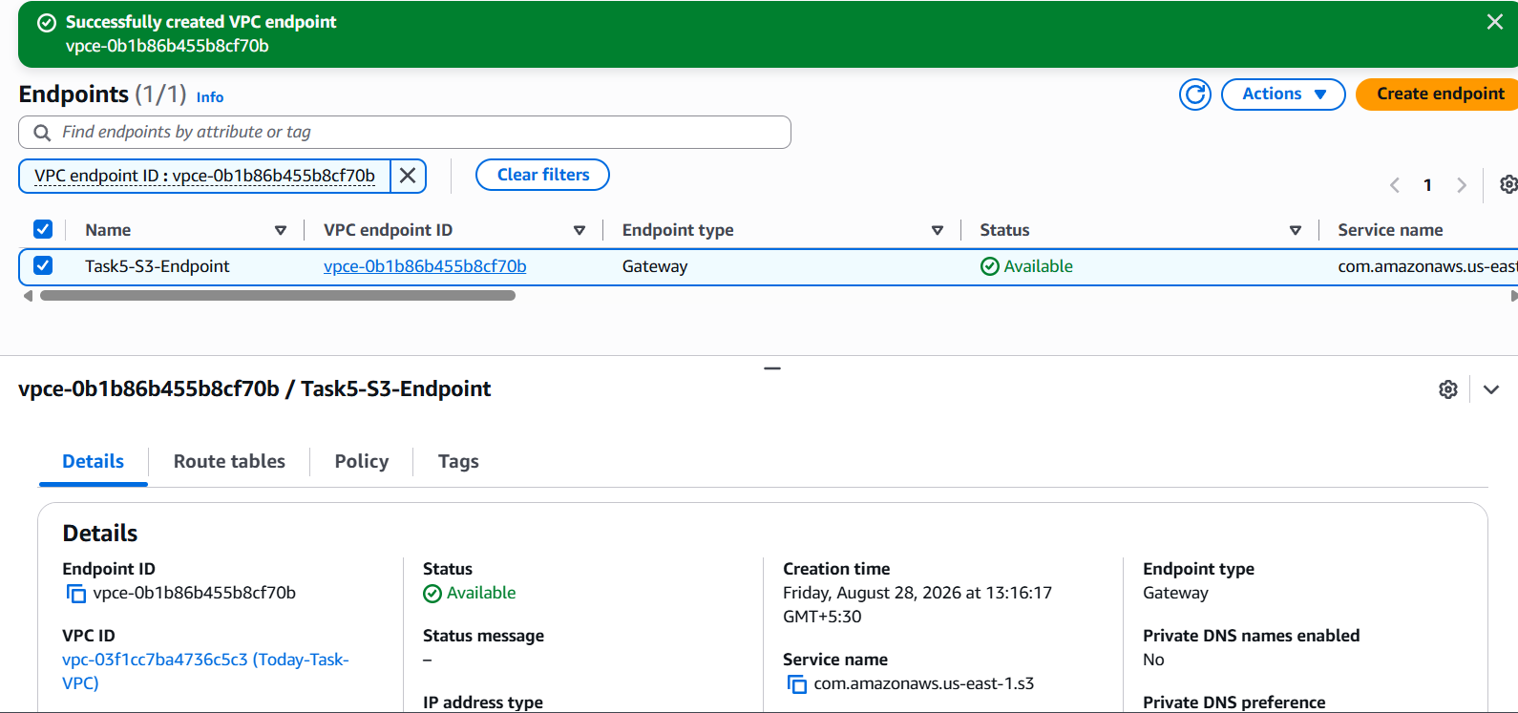

- Conclusion
This assignment demonstrates the core AWS networking concepts, including creating a VPC with public and private subnets, establishing cross-Region and cross-account VPC peering, setting up a VPC Transit Gateway, and creating a VPC Endpoint for private access to AWS services. It provides practical experience with VPC connectivity, routing, and network design in AWS.

